Exercise 1: Control Structures

Scenario 1: The bank wants to apply a discount to loan interest rates for customers above 60 years old.

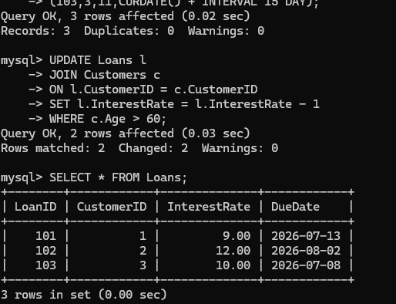

Scenario 2: A customer can be promoted to VIP status based on their balance.

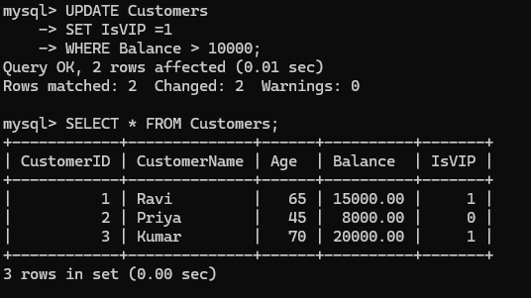
Scenario 3:
